# **LoRA and QLoRA: Efficient Fine-Tuning Techniques for Large Language Models**

## **Abstract**

This research examines Low-Rank Adaptation (LoRA) and Quantized Low-Rank Adaptation (QLoRA), two parameter-efficient fine-tuning techniques that address computational constraints in adapting large language models. LoRA reduces trainable parameters through low-rank matrix decomposition, while QLoRA incorporates 4-bit quantization for further memory reduction.

## **1. Introduction**

Large language models (LLMs) with billions of parameters present significant fine-tuning challenges due to computational and memory requirements. Traditional fine-tuning updates all model parameters, demanding substantial resources often prohibitive for researchers and organizations. Parameter-efficient fine-tuning (PEFT) methods like LoRA and QLoRA solve these challenges by leveraging the intrinsic low-dimensional structure of large models.

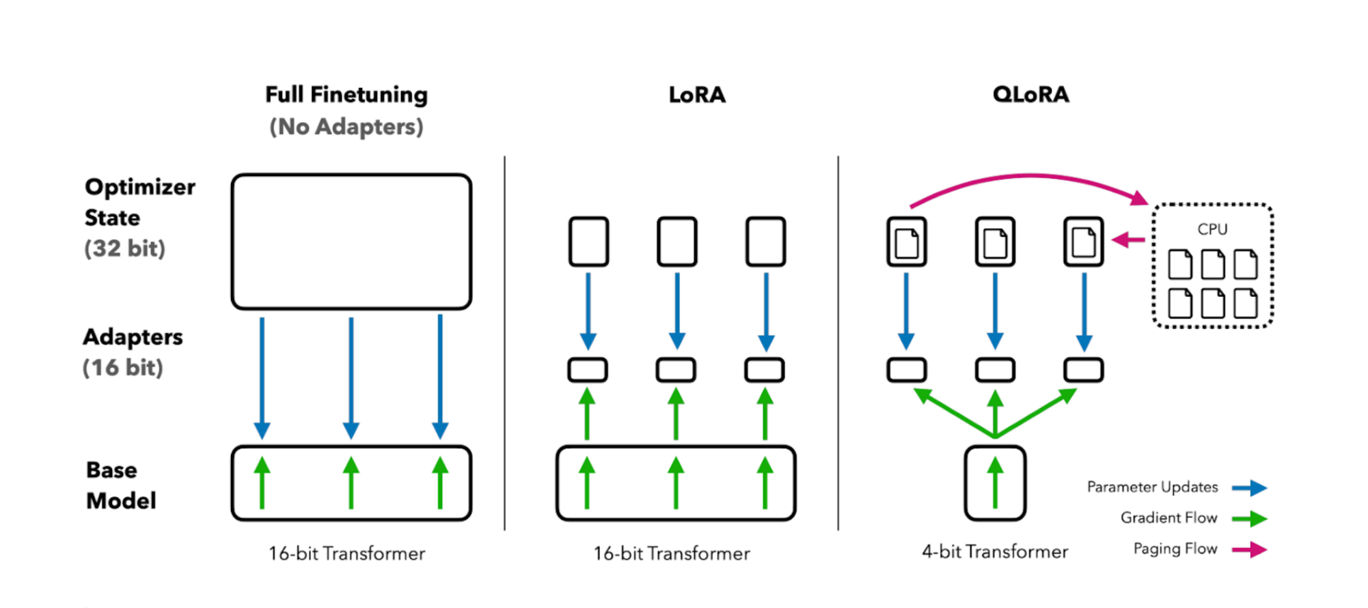

## **2. LoRA (Low-Rank Adaptation)**

### **2.1 Theoretical Foundation**

LoRA hypothesizes that over-parametrized models reside on low intrinsic dimensions, with weight changes during adaptation having low intrinsic rank. The method decomposes weight updates through low-rank matrix decomposition: **ΔW = BA**, where B ∈ R^(d×r), A ∈ R^(r×k), and r << min(d,k). During training: h = W₀x + BAx, with W₀ as frozen pre-trained weights and B, A as trainable matrices.

### **2.2 Working of LoRA**

LoRA modifies traditional fine-tuning by introducing low-rank matrices into specific neural network layers, enabling task adaptation without changing the entire model.

**1. Decomposing the Weight Matrix**: Instead of updating entire weight matrices, LoRA approximates them using two smaller low-rank matrices A and B. The adapted weight matrix is: **W' = W + A·B**, where W is the original weight matrix. This drastically reduces computational load.

**2. Training Only LoRA Parameters**: During fine-tuning, only matrices A and B are updated while original weights W remain frozen, minimizing adjustable parameters and making fine-tuning faster and more memory-efficient.

**3. Inference with Adapted Weights**: After fine-tuning, the adapted weight matrix W' is used for inference, maintaining efficiency while enabling task-specific predictions.

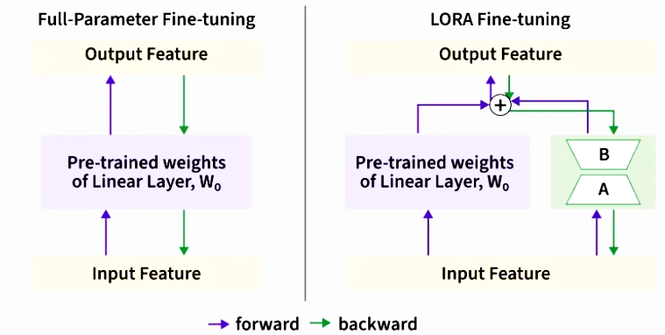

### **2.3 Implementation and Advantages**

LoRA targets attention matrices (Q, K, V, output projections) in Transformer layers with configurable rank r and scaling factor α/r. It offers 99%+ parameter reduction, small adapter storage (few MB), modularity for task-specific adapters, and performance preservation comparable to full fine-tuning.

## **3. QLoRA (Quantized Low-Rank Adaptation)**

### **3.1 Innovation and Components**

QLoRA enables fine-tuning 65B parameter models on single 48GB GPUs while preserving 16-bit performance. It backpropagates gradients through frozen, 4-bit quantized models while maintaining LoRA matrices in higher precision (bfloat16). Key components include: 4-bit NormalFloat (NF4) optimized for normally distributed weights, double quantization of quantization constants, and paged optimizers using NVIDIA unified memory.

### **3.2 Working of QLoRA**

QLoRA combines quantization with LoRA's low-rank adaptation to achieve extreme memory efficiency while maintaining performance.

**1. 4-bit Quantization of Base Model**: The pre-trained model weights are quantized to 4-bit precision using NormalFloat (NF4), a data type specifically designed for normally distributed weights. This reduces memory usage by approximately 75% compared to 16-bit representations.

**2. LoRA Adaptation in Higher Precision**: While base weights are quantized, LoRA matrices A and B remain in 16-bit (bfloat16) precision. During forward pass: **h = W_4bit·x + LoRA_16bit(x)**, where W_4bit represents quantized frozen weights and LoRA_16bit performs adaptation calculations in higher precision.

**3. Gradient Flow Through Quantized Weights**: During backpropagation, gradients flow through the quantized base model to update only the LoRA parameters. The quantized weights remain frozen, ensuring memory efficiency while enabling effective adaptation.

**4. Double Quantization Optimization**: QLoRA further reduces memory by quantizing the quantization constants themselves, achieving additional memory savings without significant performance loss

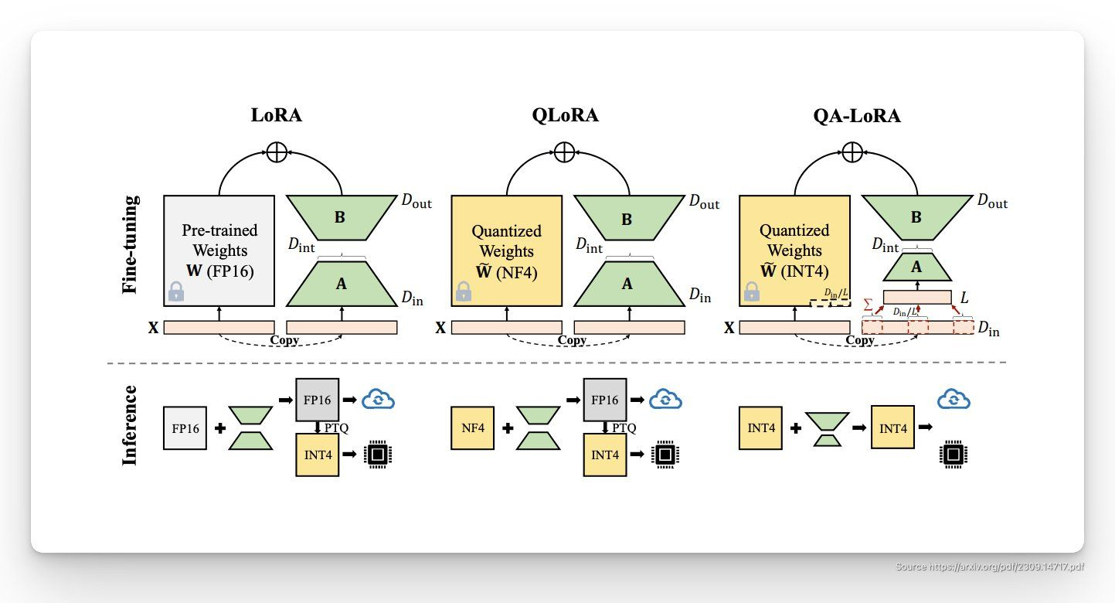

### **3.3 Efficiency and Performance**

QLoRA with optimal settings (r=256, alpha=512) requires only 17.86 GB with AdamW optimizer. Research on LLaMA-7B shows both LoRA (rank 16) and QLoRA (rank 64) achieve competitive performance with full fine-tuning approaches.

## **4. Comparative Analysis and Applications**

### **4.1 Resource Requirements and Use Cases**

**Full Fine-tuning** updates all parameters requiring substantial GPU memory. **LoRA** provides 99%+ parameter reduction suitable for moderate resources, multiple task adaptations, and interpretability needs. **QLoRA** offers additional memory reduction through quantization, optimizing resource-constrained environments and very large model fine-tuning (65B+ parameters).

### **4.2 Impact and Adoption**

These techniques democratize large model fine-tuning, enabling smaller organizations and researchers to adapt state-of-the-art models. They've seen widespread adoption across research institutions, companies, and open-source projects, transforming accessibility of advanced AI capabilities.

## **5. Limitations and Future Directions**

Current limitations include performance gaps with full fine-tuning for some tasks, expertise requirements for rank selection, and subtle performance degradations from QLoRA quantization. Future research focuses on optimal rank selection strategies, advanced quantization techniques, hybrid PEFT approaches, and theoretical understanding of adaptation effectiveness.

## **6. Conclusion**

LoRA and QLoRA have fundamentally transformed LLM fine-tuning by making it accessible, efficient, and practical. LoRA's decomposition of weight updates into lower rank matrices effectively balances adaptation needs with computational efficiency, while QLoRA extends this through quantization innovations. These techniques represent a paradigm shift from resource-intensive full fine-tuning to intelligent, parameter-efficient strategies, demonstrating that effective model adaptation doesn't require updating every parameter. As foundational techniques, they continue enabling broader adoption of sophisticated AI systems across diverse domains and resource constraints.

## **References**

[1] Hu, E. J., Shen, Y., Wallis, P., Allen-Zhu, Z., Li, Y., Wang, S., Wang, L., & Chen, W. (2021). LoRA: Low-Rank Adaptation of Large Language Models. *arXiv preprint arXiv:2106.09685*.

[2] Dettmers, T., Pagnoni, A., Holtzman, A., & Zettlemoyer, L. (2023). QLoRA: Efficient Finetuning of Quantized LLMs. *arXiv preprint arXiv:2305.14314*.

[3] GeeksforGeeks. (2024). What is Low Rank Adaptation (LoRA)? Retrieved from <https://www.geeksforgeeks.org/deep-learning/what-is-low-rank-adaptation-lora/>

[4] GeeksforGeeks. (2024). Fine-Tuning using LoRA and QLoRA. Retrieved from<https://www.geeksforgeeks.org/deep-learning/fine-tuning-using-lora-and-qlora/>